|  |  |
| --- | --- |
| THE UNIVERSITY OF NEWCASTLE | |
|  | |
| Executive committee | 24 OCTOBER 2022 |
|  |  |
| University performance in the Times Higher Education World University Rankings 2023 edition | |

# Draft Resolution

The Executive Committee RESOLVE to:

1. ***Discuss the analysis of the University’s performance in the THE WUR 2023 edition and acknowledge the strong dependence of citations on driving ranking change.***
2. ***Prioritise and leverage any strategy to improve citations, including recruitment of high-performing researchers and a sustained cultural shift in publishing towards open access.***
3. ***Undertake research to understand the low scores across both teaching and research reputation and action program to drive growth (subject of adjacent EC paper).***

# Executive Summary

This report provides an update on the performance of the University and other Australian universities in the 2023 edition of the Times Higher Education (THE) World University Rankings (WUR). **The University moved up one band from 251-300 to 201-250.** The pillar scores for Teaching, Research and Citations have increased slightly since the 2022 release which has driven the ranking increase. Universities that have achieved rapid and significant ranking growth used increased citations as the main driver for improvement. Further strategies to deliver high-quality research through targeted recruitment of high performing academics, with increased international and industry collaboration, and new cultural shifts in publications strategies will deliver strong citations and thus ranking growth in the coming years. Achieving and then maintaining a top-200 ranking is important for the Universities reputation in a hyper-competitive international student market. Currently the scores for teaching and research reputation for the University of Newcastle are some of the lowest among the non-Go8 universities. Understanding and delivering improvements in these scores would deliver ranking growth in the coming years (and is the subject of an incoming EC paper).

# Background

The Times Higher Education World University Ranking evaluates universities across core activities such as teaching, research, knowledge transfer and international outlook. It uses 13 calibrated performance metrics to provide comprehensive and balanced comparisons, trusted by students, academics, university leaders, industry, and governments. These 13 metrics are grouped into five pillars (previously called indicators): Teaching (the learning environment); Research (volume, income, and reputation); Citations (research influence); International Outlook (staff, students and research); and Industry Income (knowledge transfer). See **Appendix A** for a full outline of the methodology including a breakdown of the pillars and metrics.

# Matters for Noting and/or Discussion

**Statistical Analysis**

***Figure 1* below shows the time-series of the derived rank for the University of Newcastle from 2016 to 2023 (left) and the pillar scores (right).** The University of Newcastle has an average rank of 280 (from 2017-2023) and the expected variation around this value is ±41 ranks based on the average standard deviation in their ten-rank band. In comparison, a university with a rank of 30 (e.g., University of Melbourne) would only vary by 3 ranks per year, unless significant change has taken place.

For the University of Newcastle, although four consecutive rises in rank have been observed (2019-2023), the variations are in-line with the expected volatility (±41) at this average rank (shaded region ***Figure 1***). **A further positive result next year outside the expected volatility range would give a statistically significant increase in ranking for the University in terms of a strong upward trajectory.**

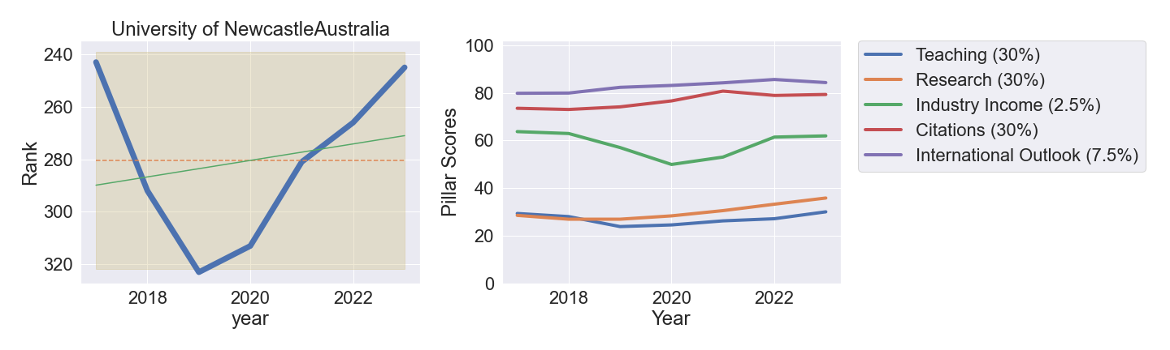

**Figure 1:** **University of Newcastle Rank and Pillar scores**. (Left) Derived rank for the University of Newcastle (blue), including average rank (orange dash), best fit (green line) and expected volatility range (shaded region). (Right) The pillar scores versus time with the given pillar weighting shown in the legend as a percentage of the final score.

**From the right-hand plot of *Figure 1* the scores for both Teaching (+1.9 points) and Research (+3.2 points) have risen slowly over several years and the score for Citations has increased slightly from last year (+0.4 points). Breaking this further down into the metric scores, *Figure 2* shows scores that have changed by greater than 15 points from 2016-2023. The University has achieved strong growth in Publications per staff (6%) and Research Income (6%) which should be celebrated.**

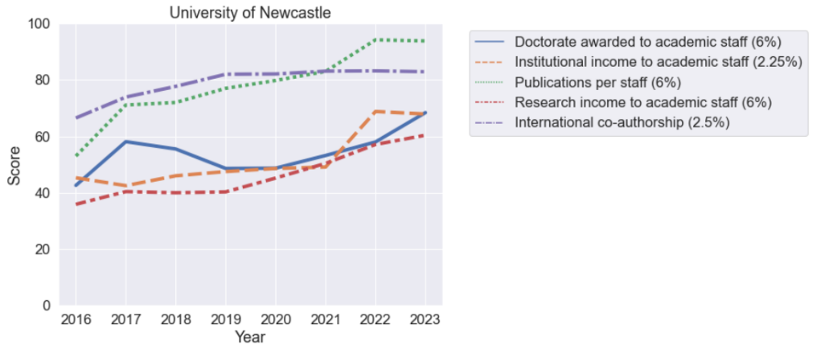

**Figure 2: University of Newcastle Metric Scores** restricted to those with changes greater than 15 points (2016-2023).

**How do Universities significantly change their ranking?**

Using THE Datapoints data, *all* universities worldwide were analysed and those that increased above and beyond the expected volatility range with significant linear increase in rank were identified. The plots in ***Figure 3*** show a sample of universities (worldwide) that have seen significant growth in the past years, with the left-hand plot showing the ranking change (with volatility band), and the right plot showing the pillar scores.

**The largest driving factor for this growth is increased Citations**, and there were many more examples of this trend across all universities. The citations pillar does not have any subsidiary metrics and purely tracks the Field Weighted Citation Impact across the university. For example, Bournemouth University delivers a strong publication output in Medical Science with a significant number of highly cited papers reported in The Lancet, which are co-authored with high-quality neighbouring Universities (e.g., Oxford, Southampton, UCL, Cambridge). A similar trend is seen for the University of Lincoln and Birmingham City University. These universities therefore delivered growth in the THE WUR by publishing in high-quality journals, in fields which garner significant citations, with collaborators from more prestigious universities.

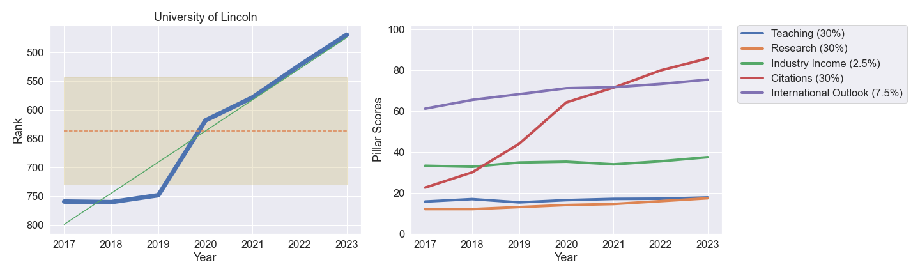

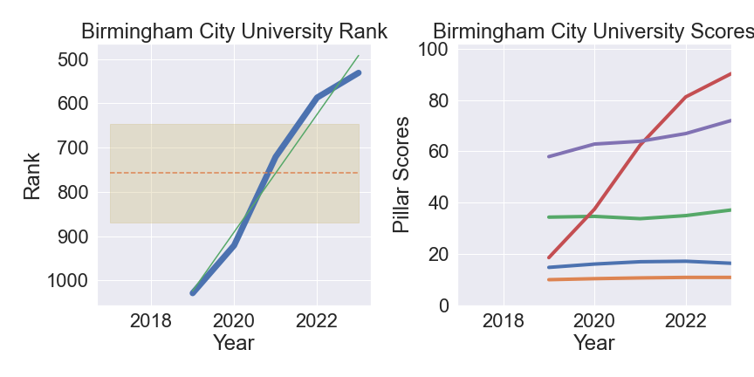

Figure 3: Universities that have achieved significant ranking growth from 2017-2023. The Citations pillar drives the ranking increase.

***Recommendation 1: Prioritise and leverage any strategy to improve citations, including recruitment of high-performing researchers and co-authorship with highly ranked peer institutions with a sustained cultural shift in publishing towards open access.***

**Significant movements in the domestic market**

**Table 1 summarises the THE WUR results of the domestic universities. This table has been ordered by the Universities with statistically significant changes (bold/top). Universities that are shaded have not changed significantly between 2017-2023.**

**Table 1: Summary of ranking change for domestic universities**

|  |  |  |  |  |  |  |  |  |  |
| --- | --- | --- | --- | --- | --- | --- | --- | --- | --- |
| **University** | **Rank  YoY** | **Score  YoY** | **Expected Rank  Variation** | **Significant  Change** | **Teaching  YoY** | **Research  YoY** | **Citations**  **YoY** | **Industry  Income YoY** | **International  Outlook YoY** |
| **Monash University** | **+13** | **3.7** | **± 10.5** | **Yes** | **2.6** | **7** | **2.7** | **-0.8** | **0** |
| **University of Adelaide** | **+23** | **3.5** | **± 18.4** | **Yes** | **7.1** | **6.6** | **-2.1** | **-0.2** | **-0.1** |
| **University of Technology Sydney** | **+10** | **1.5** | **± 26.6** | **Yes** | **0.4** | **-1.6** | **6.8** | **-5.3** | **-1.2** |
| **Macquarie University** | **+17** | **1.8** | **± 32.6** | **Yes** | **-0.3** | **1.3** | **4.7** | **1.6** | **0.3** |
| **La Trobe University** | **-47** | **-1.7** | **± 44.8** | **Yes** | **-1.7** | **-1.1** | **-3.1** | **5.1** | **-1.4** |
| **Curtin University** | **+4** | **0.9** | **± 45.6** | **Yes** | **1.3** | **0.9** | **0.5** | **5** | **-0.3** |
| **Western Sydney University** | **-12** | **0** | **± 47.2** | **Yes** | **-0.4** | **1.2** | **-1.1** | **1.7** | **0** |
| **RMIT University** | **+12** | **1.3** | **± 57.1** | **Yes** | **1.8** | **0.6** | **2** | **1.6** | **-0.3** |
| **University of Canberra** | **-84** | **-4.9** | **± 40.6** | **Yes** | **-7.9** | **-1.8** | **-6** | **-1.2** | **-1.7** |
| **Bond University** | **+290** | **11.1** | **± 74.9** | **Yes** | **0** | **1.3** | **37.5** | **1.9** | **-7.3** |
| **Australian Catholic University** | **-22** | **-0.1** | **± 60.3** | **Yes** | **-1.2** | **-1.6** | **2.4** | **1.8** | **-0.3** |
| **University of Southern Queensland** | **+98** | **4.5** | **± 85.5** | **Yes** | **2.9** | **0.5** | **11.3** | **2.6** | **0.5** |
| University of Melbourne | -1 | -0.2 | 5.2 | No | -0.4 | 2.1 | -2.6 | 3.2 | -0.4 |
| Australian National University | -7 | -1 | 8.2 | No | 1.5 | 1.5 | -6 | -2.2 | -0.5 |
| University of Sydney | 3 | 1 | 8.9 | No | 1.3 | 3.6 | -2 | 7.1 | -0.3 |
| The University of Queensland | 3 | 1.1 | 9.5 | No | 0.9 | 4.5 | -1.5 | -4.2 | -0.2 |
| UNSW Sydney | -1 | 0.1 | 11.7 | No | 0.7 | -1.4 | 1.8 | -9.2 | -0.1 |
| The University of Western Australia | 3 | 0.8 | 19.4 | No | 0.5 | 4.5 | -2.4 | 4.2 | -1.1 |
| Queensland University of Technology | -14 | -0.3 | 30.6 | No | -3 | 3 | -0.8 | 0.1 | -0.7 |
| University of Newcastle | 21 | 1.7 | 41.5 | No | 2.9 | 2.6 | 0.4 | 0.5 | -1.3 |
| Charles Darwin University | 157 | 5.8 | 67.8 | No | -0.3 | 3.2 | 16.5 | -0.9 | 0.4 |
| University of Wollongong | -16 | -0.4 | 36.5 | No | 0.6 | 0.6 | -2.5 | 1.4 | -0.7 |
| James Cook University | -92 | -3.2 | 39.6 | No | -2.1 | -1.7 | -10.6 | -2.1 | 15.1 |
| Griffith University | -44 | -1.1 | 39.1 | No | -0.4 | 0.5 | -4 | 2.2 | 0.4 |
| University of South Australia | -18 | 0.2 | 42.7 | No | -0.5 | -0.5 | 2.3 | -4.8 | -0.9 |
| Deakin University | 1 | 0.9 | 46.3 | No | -1.5 | 0.7 | 3.9 | 1.8 | -0.5 |
| University of Tasmania | 5 | 1 | 50.2 | No | -0.5 | 2.5 | 1.2 | 1.1 | -0.2 |
| Victoria University | -99 | -1.6 | 56.9 | No | -1.5 | -1.9 | 0.2 | 0.6 | -8.7 |
| Swinburne University of Technology | 39 | 2.2 | 56.1 | No | 0.4 | 1.8 | 5.1 | 3 | -0.3 |
| Flinders University | -38 | -1 | 44.5 | No | 1.8 | 2.1 | -7.5 | 2.3 | -0.1 |
| Murdoch University | 109 | 4.1 | 68.2 | No | 0.7 | 0.6 | 12.1 | 0.5 | 0.6 |
| Central Queensland University | 177 | 6.3 | 97.8 | No | 2.3 | 4.2 | 14.5 | 2.4 | -1.4 |
| Southern Cross University | -27 | 0.7 | 89.5 | No | -1 | 1.9 | -1.1 | 3 | 9.3 |
| Edith Cowan University | 53 | 2.8 | 70.8 | No | 0.9 | 0.9 | 7.2 | 1.9 | 0.9 |
| University of the Sunshine Coast | -102 | -1.2 | 97.6 | No | -2.7 | -0.6 | -0.3 | -0.3 | -1.4 |
| Federation University Australia | 178 | 6.6 | 110 | No | 1 | 1 | 19.3 | 1.6 | 2.4 |
| Charles Sturt University | -216 | -3.1 | 143.6 | No | 0.9 | -0.9 | -9.2 | 1.8 | -5.3 |

**Appendix B shows the full time-series of the Universities that have achieved significant ranking increase (2017-2023). Notably and as discussed above the citation pillar drives a lot of the change (red line in figures).**

**How did the University of Adelaide achieve significant ranking change?**

**The one exception to the general trend of rankings growth being derived from Citations was the University of Adelaide which achieved growth through the Teaching and Research pillars. Breaking the pillar scores down into the individual metrics (see *Figure 4*), despite dropping in Citations, an increase in Teaching Reputation (+11.1 points @ 15% between 2022/23) and Research Reputation (+9.8 points @ 18%) has driven the ranking increase. A statistical analysis of the Teaching and Research reputation scores across all universities shows that over the years these indicators are ’stubborn‘ and record lower levels of growth than through citations. Despite this, the University of Adelaide have been able to drive significant change in these metrics.**

**For the University of Newcastle, both the teaching and research reputation metrics have a large amount of potential for upward growth and are highly weighted; any leverage that can be utilised to increase the scores should be pursued. This will be discussed further below and is also the subject of an adjacent EC paper “University reputation through the lens of independent external surveys”. A deeper understanding of why the University of Newcastle is not receiving more votes is required.**

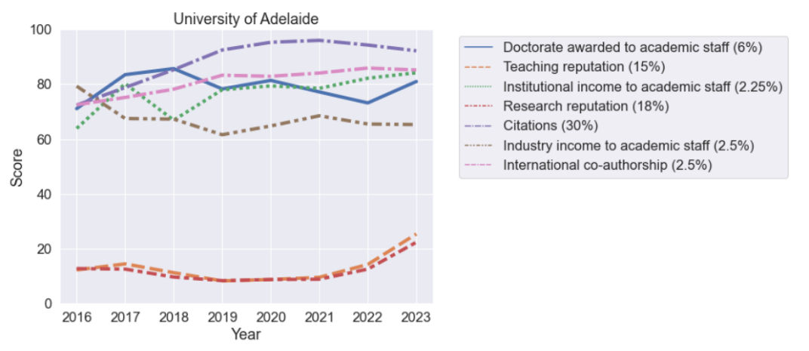

**Figure 4:** Metric Scores for the University of Adelaide. Research and Teaching reputation have seen significant growth in the past year.

**The University of Canberra dropped after years of significant growth. Th University of Canberra has had strong performance in previous years, leading to strong ranking growth (see Appendix A for time-series) but has dropped 84 ranks in the latest ranking. The major drop was caused by two major highly cited papers dropping out of the data collection period and also possible movements in highly cited researchers.**

**There are two major takeaways here: (1) short-term strategies can yield results, but a high-quality research pipeline must be sustained, and (2) due to the data collection period, the targeting and subsequent hire of high-performing researchers will take several years to yield results in the ranking.**

**Metric Analysis**

***Figure 5* below shows the scores for the University of Newcastle in black across all metrics. The coloured points are a selection of our peers (see appendix C for a current list) which are largely domestic universities, while the box plots represent the statistics of all Universities worldwide. Appendix D and E gives tables of the raw scores and changes in metrics from 2022 to 2023 for the peers. For eleven of the thirteen metrics, the University of Newcastle is in the top quartile. As noted above, the major anomalies on this plot are the Teaching and Research reputation scores. Although the University of Newcastle performs above the worldwide median, the median score is exceptionally low, meaning that many Universities receive a minimal score, or score of zero in this metric. The coloured points represent Australian peers with a range of universities scoring well (e.g., The University of Adelaide scores 25.4 in Teaching Reputation versus 7.6 for Newcastle). Small increases in both the teaching and research reputation scores would deliver a large impact on the overall ranking.**

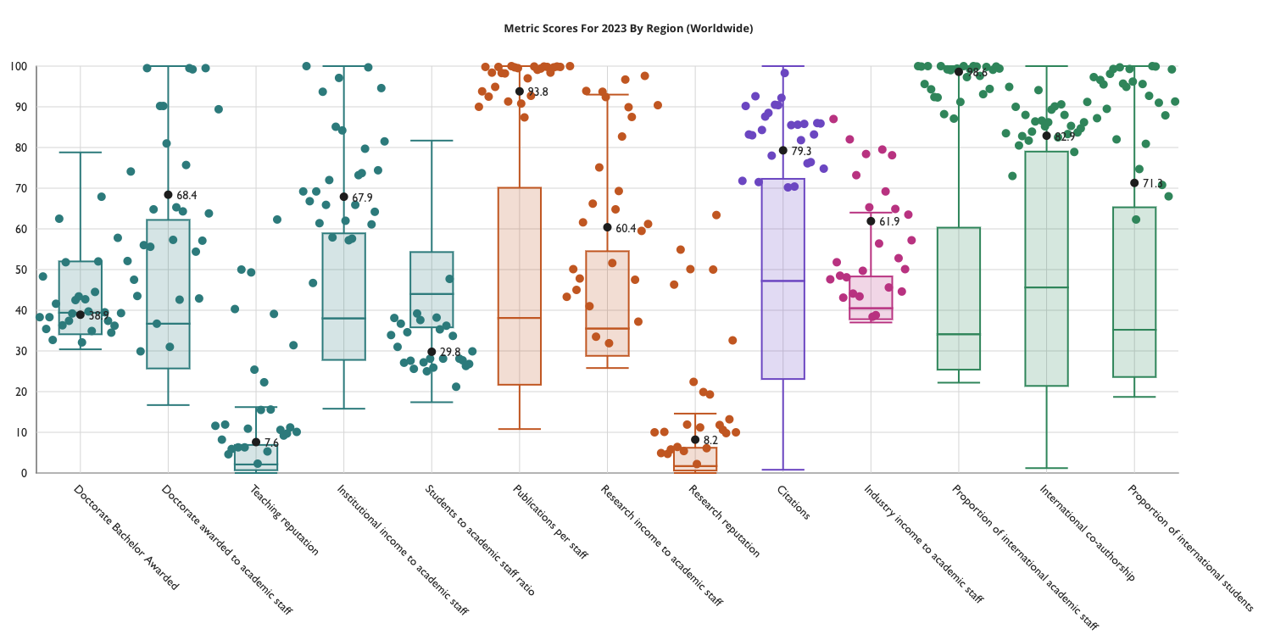

**Figure 5:** Metric scores for 2023 for selected University peers. The University of Newcastle is shown by the black circles.

***Recommendation 2: Undertake research to understand the low scores across both teaching and research reputation with an action plan and related reputation improvement program to drive growth.***

**Professor Jennifer Milam**

**Pro Vice-Chancellor Academic Excellence**

# Document History

|  |  |  |
| --- | --- | --- |
| **Prepared by** | Dr Martin Bell, Data Scientist, Academic Excellence | 18 October 2022 |
| **Team members involved in preparation of the report** | Dr Yik Teo, Strategic Analyst, Academic Division | 18 October 2022 |
| **Edited by** | Jemma Bowman, Senior Project Officer, Academic Excellence | 18 October 2022 |
| **Reviewed by** | Professor Jennifer Milam, PVC (Academic Excellence) | 19 October 2022 |
| **Approved for Council Track** | Professor Alex Zelinsky, Vice-Chancellor and President |  |
| **Distributed to** | Executive Committee |  |

# Appendices

Appendix A: THE methodology.

Appendix B: Time series of domestic Universities that have achieved significant rank change.

Appendix C: List of peers in THE Datapoints.

Appendix D: Raw data for university peers

Appendix E: Year on year change in metric scores for all University peers.

**Appendix A: Methodology**

THE WUR uses 13 performance metrics to rank world universities. **Table 2** below provides a summary of the metrics and their corresponding weights.

**Table 2: THE WUR indicators and weights**

To be ranked, THE asks institutions to provide institutional data that covers student, staff and income information. This contributes to 28.5% of the total weight. The rest of the data is sourced from Elsevier through:

1. The Academic Reputation Survey questionnaire that targets experienced, published scholars, who offer their views on excellence in research and teaching within their disciplines and at institutions with which they are familiar. Academics can vote for their own institution. This accounts for 15% (teaching) and 18% (research), a total of 33%.
2. Bibliometric data on research productivity, citations, and co-author publications. Publication types—articles, reviews, proceedings, books, and book chapters—are considered. A five-year publication window for papers and a six-year citation window is used to provide scores to institutions.

The data received from institutions and Elsevier is analysed by THE using a standardisation approach to calculate scores for each metric. Using the weightings for Teaching (30%), Research (30%), Citations (30%), International Outlook (7.5%) and Industry Income (2.5%) overall scores for institutions are calculated.

THE awards an overall score and specific rank to the top 200 universities. Universities beneath the top 200 are given a ranking band within intervals of 50 for the next 200 universities (e.g., 201-250 or 351-400), intervals of 100 for universities between 400 and 600, intervals of 200 for universities between 600 and 1,200 and universities below 1,200 receives a rank of 1201+. All universities below the top 200 also get a score band. Using the percentage weightings for each broad indicator, the overall score was calculated to determine the estimated world and Australian rank for each university. **Please note these derived scores and ranks are for internal use only**.

Note, THE have announced that the 2024 methodology will change slightly and some of the changes will impact how citations are counted and normalised. Early indications from THE show that Australian Universities will likely suffer a ranking decrease because of this change.

**Appendix B:** Time series of domestic Universities that have achieved significant rank change.

|  |  |  |
| --- | --- | --- |
|  |  |  |
|  |  |  |
|  |  |  |

|  |  |  |
| --- | --- | --- |
|  |  |  |

**Appendix C:** List of peers in THE Datapoints.

| **Institution** |
| --- |
| University of Newcastle |
| RMIT University |
| National University of Singapore |
| La Trobe University |
| Curtin University |
| University of Canberra |
| University of Tasmania |
| The University of Queensland |
| Western Sydney University |
| University of Sydney |
| James Cook University |
| University of Technology Sydney |
| Monash University |
| University of Adelaide |
| Australian Catholic University |
| University of Otago |
| University of Auckland |
| University of South Australia |
| The University of Western Australia |
| Australian National University |
| University of Melbourne |
| Macquarie University |
| Griffith University |
| Deakin University |
| Queensland University of Technology |
| UNSW Sydney |
| University of Wollongong |

**Appendix D:** Raw data for university peers

|  |  |  |  |  |  |  |  |  |  |  |  |  |
| --- | --- | --- | --- | --- | --- | --- | --- | --- | --- | --- | --- | --- |
| **University** | **Doctorate  Bachelor Awarded** | **Doctorate awarded  to academic staff** | **Teaching  reputation** | **Institutional income  to academic staff** | **Students to  academic staff ratio** | **Publications per staff** | **Research income  to academic staff** | **Research  reputation** | **Industry income  to academic staff** | **Proportion of international  academic staff** | **International  co-authorship** | **Proportion of  international students** |
| **University of Newcastle** | **0.05** | **0.35** | **58.9** | **689223** | **29.5** | **12.6** | **152616** | **98.3** | **47858** | **42.10%** | **52.80%** | **17.60%** |
| University of Auckland | 0.06 | 0.32 | 160.5 | 560943 | 22.1 | 12.5 | 167140 | 214.8 | 37164 | 38.30% | 58.50% | 31.50% |
| James Cook University | 0.04 | 0.17 | 40.2 | 564047 | 20.1 | 11.9 | 39849 | 51.9 | 12511 | 45.20% | 56.20% | 31.70% |
| Griffith University | 0.04 | 0.25 | 63.7 | 602716 | 32.9 | 13.8 | 79747 | 115.2 | 30354 | 51.10% | 50% | 17.50% |
| University of Canberra | 0.01 | 0.09 | 26.7 | 706706 | 35.5 | 11.8 | 72708 | 42 | 11905 | 33.40% | 49.10% | 26% |
| Curtin University | 0.05 | 0.21 | 85.1 | 293879 | 20.8 | 12.9 | 51950 | 107.2 | 15124 | 58.90% | 60.20% | 31.50% |
| RMIT University | 0.05 | 0.24 | 74.9 | 706560 | 23.6 | 10.4 | 68112 | 108.2 | 20615 | 62.50% | 54.20% | 34.30% |
| La Trobe University | 0.03 | 0.22 | 51.7 | 674479 | 27.4 | 15.7 | 112264 | 48.7 | 28505 | 35.20% | 47.70% | 33% |
| National University of Singapore | 0.1 | 0.45 | 1345.9 | 2429653 | 19.8 | 14.2 | 620447 | 2315.2 | 110076 | 57.30% | 65.30% | 24.60% |
| The University of Queensland | 0.18 | 1 | 320.7 | 1190288 | 34.2 | 19.3 | 404007 | 623.5 | 93991 | 31.20% | 57.10% | 40.80% |
| University of Sydney | 0.12 | 0.32 | 418.1 | 743710 | 19 | 15.3 | 161782 | 820.4 | 71677 | 27.80% | 54.20% | 44.70% |
| Macquarie University | 0.05 | 0.62 | 71.1 | 1767426 | 69 | 16.2 | 239723 | 124.7 | 53861 | 32.10% | 55% | 27.10% |
| Deakin University | 0.03 | 0.18 | 62.7 | 640973 | 33.9 | 12.7 | 49331 | 103.9 | 14896 | 33.60% | 53.10% | 25% |
| Monash University | 0.07 | 0.56 | 447.3 | 1360371 | 42.5 | 18 | 355868 | 731.8 | 84269 | 27% | 56% | 40.60% |
| QUT | 0.04 | 0.26 | 73.8 | 778017 | 37.9 | 15.6 | 129248 | 141.7 | 25258 | 44.70% | 54.20% | 16.50% |
| University of Technology Sydney | 0.05 | 0.49 | 71.4 | 959378 | 35.1 | 20 | 192675 | 129 | 24581 | 44.20% | 63% | 30.70% |
| UNSW Sydney | 0.16 | 0.82 | 213.4 | 1227598 | 36.3 | 19.6 | 394549 | 376 | 51157 | 54.70% | 56.20% | 40.20% |
| University of Tasmania | 0.07 | 0.28 | 42.8 | 606696 | 22.9 | 12.2 | 150234 | 61.8 | 21463 | 31.30% | 55.30% | 36% |
| University of Adelaide | 0.08 | 0.49 | 201.7 | 942060 | 32.8 | 19.1 | 382009 | 273.5 | 54688 | 47.10% | 55.80% | 32.30% |
| Western Sydney University | 0.04 | 0.25 | 31.9 | 662866 | 40.3 | 12.8 | 58282 | 71.5 | 13877 | 59.70% | 51.70% | 21.90% |
| University of Wollongong | 0.05 | 0.34 | 72.1 | 891195 | 29.1 | 17.9 | 122527 | 102.8 | 38810 | 46.80% | 59.20% | 27.30% |
| University of South Australia | 0.03 | 0.18 | 37.8 | 663607 | 32.9 | 10.8 | 133097 | 64.7 | 87020 | 45.30% | 51.60% | 21.40% |
| Australian Catholic University | 0.01 | 0.09 | 14.8 | 614496 | 39.1 | 7.5 | 15380 | 22.5 | 2837 | 30.20% | 51.20% | 14.60% |
| University of Otago | 0.07 | 0.29 | 97.4 | 556326 | 19.7 | 10.2 | 112884 | 106.2 | 3605 | 60% | 57.60% | 18.90% |
| University of Melbourne | 0.22 | 0.83 | 590.5 | 860406 | 23.8 | 16.7 | 286146 | 1008 | 83513 | 39.10% | 54% | 47.40% |
| The University of Western Australia | 0.08 | 0.34 | 95.4 | 761446 | 21.3 | 22 | 260832 | 212.3 | 62795 | 69.40% | 61.30% | 28.50% |
| Australian National University | 0.12 | 0.4 | 275.5 | 768228 | 14.6 | 14.7 | 356461 | 680.4 | 16694 | 56.90% | 58.30% | 51.50% |

**Appendix E:** Year on year change in metric scores for all university peers.

|  |  |  |  |  |  |  |  |  |  |  |  |  |  |
| --- | --- | --- | --- | --- | --- | --- | --- | --- | --- | --- | --- | --- | --- |
| **University** | **Doctorate Bachelor Awarded** | **Doctorate awarded to academic staff** | **Teaching reputation** | **Institutional income to academic staff** | **Students to academic staff ratio** | **Publications per**  **staff** | **Research income to academic staff** | **Research reputation** | **Citations** | **Industry income to academic staff** | **Proportion of international academic staff** | **International co-authorship** | **Proportion of international students** |
| University of Newcastle | -2.1 | 10.4 | 1.9 | -0.9 | -0.1 | -0.4 | 3.3 | 3.2 | 0.4 | 0.5 | 0 | -0.3 | -3.6 |
| University of Auckland | -1.9 | 5.5 | 3.6 | -1.5 | 0.7 | 0.1 | -11 | 0.4 | 0.7 | -13 | -0.5 | 0.2 | -0.5 |
| James Cook University | -5.3 | -7.5 | 0.1 | -4.3 | 0.2 | -6.3 | -1.2 | -0.3 | -10.6 | -2.1 | 2.2 | 0.1 | 42.8 |
| Griffith University | -2.9 | 1.6 | -1 | 2.8 | -1.8 | 0.1 | 1.7 | 0.2 | -4 | 2.2 | 0.3 | 0.7 | 0 |
| University of Canberra | -6.1 | -36.8 | 0.5 | -4.3 | 0.1 | -0.9 | -8 | 0.1 | -6 | -1.2 | -4.1 | 2.9 | -4.1 |
| Curtin University | -2.1 | 3.3 | 1.8 | -0.4 | 0 | 0.7 | -1.4 | 1.8 | 0.5 | 5 | 0 | -0.3 | -0.6 |
| RMIT University | -2.3 | 3.3 | 2.3 | 1 | -0.1 | -1.7 | 0.5 | 1.3 | 2 | 1.6 | 0 | -1 | 0.1 |
| La Trobe University | -4 | -7.3 | 0 | -5.8 | 3.4 | 0.1 | -0.1 | -1.7 | -3.1 | 5.1 | -1.3 | -0.4 | -2.4 |
| National University of Singapore | -0.8 | 3.2 | -0.7 | 0 | -1.2 | 4.1 | 0 | 2.6 | 2.9 | 11.6 | 0 | -0.4 | -0.7 |
| The University of Queensland | 5.4 | 0 | 0.9 | -0.5 | 0.7 | -0.1 | 1 | 7.3 | -1.5 | -4.2 | -1.4 | 0.9 | -0.1 |
| University of Sydney | 4.7 | 10.9 | -2.6 | 0.4 | 0.7 | 0.1 | 2.9 | 5 | -2 | 7.1 | 0.1 | -1 | -0.1 |
| Macquarie University | -2.9 | 0 | 0 | -0.1 | 0.1 | -0.1 | 1.9 | 1.4 | 4.7 | 1.6 | 3 | 0.5 | -2.7 |
| Deakin University | -3.8 | -1.3 | -1.3 | -4.2 | 0 | -0.4 | -0.2 | 1.4 | 3.9 | 1.8 | 1.2 | 1.7 | -4.6 |
| Monash University | -1.5 | 2.6 | 4.3 | -0.7 | 0.4 | 0 | 4.5 | 10.2 | 2.7 | -0.8 | 0.6 | 0 | -0.5 |
| QUT | -4.5 | -14.9 | 1.3 | -5.3 | 0.8 | 0 | 4.7 | 3.5 | -0.8 | 0.1 | 0 | 0.6 | -2.5 |
| UTS | -1.9 | 2.8 | 0.5 | -7.8 | 1.5 | 0 | -17.7 | 3.3 | 6.8 | -5.3 | -0.6 | 0.5 | -3.4 |
| UNSW Sydney | 11.2 | 8.5 | -3.8 | -2.9 | 1.4 | 0 | 2.5 | -3 | 1.8 | -9.2 | 0 | 0.3 | -0.5 |
| University of Tasmania | -1.4 | 0.2 | -0.7 | -1.1 | -0.3 | 1 | 6.1 | 1.8 | 1.2 | 1.1 | -0.2 | -0.3 | -0.1 |
| University of Adelaide | -0.5 | 7.8 | 11.1 | 2 | -0.9 | 0 | 3.6 | 9.8 | -2.1 | -0.2 | 0 | -0.7 | 0.3 |
| Western Sydney University | -2.8 | 4.4 | -2.3 | 2.1 | -0.6 | 1.8 | 3.5 | 0.2 | -1.1 | 1.7 | 0 | 0.7 | -0.8 |
| University of Wollongong | -3.1 | -2.8 | 3 | -3.6 | 0.7 | -0.1 | -0.7 | 1.3 | -2.5 | 1.4 | 0.6 | 0 | -2.8 |
| University of South Australia | -3.4 | 1.2 | -1 | 0.2 | -0.2 | -2.2 | -2.3 | 0.7 | 2.3 | -4.8 | -0.6 | -1.4 | -0.5 |
| Australian Catholic University | -4.3 | -3.2 | -0.3 | -4 | 1.1 | -4.1 | -2.5 | -0.5 | 2.4 | 1.8 | -3.2 | 1.2 | 1.1 |
| University of Otago | -1.2 | 2.6 | 1.2 | -0.7 | 1.2 | -1 | 2.5 | -0.7 | -7.3 | -0.8 | 0 | -0.4 | -5.7 |
| University of Melbourne | 5 | 0.2 | -1.2 | -6.6 | 2.3 | -0.3 | 5.8 | 1.7 | -2.6 | 3.2 | -0.7 | -0.4 | 0 |
| UWA | 0.3 | 1.4 | 1 | -4.8 | 0.2 | -0.1 | 11 | 3.9 | -2.4 | 4.2 | 0 | -1.4 | -1.9 |
| ANU | 5 | 11.9 | -3 | -10.1 | 6.5 | -0.8 | -2.3 | 3.5 | -6 | -2.2 | 0 | -1.8 | 0.2 |